Lesson Plan

Teacher:Maghiar Liliana
School: Școala Gimnazială “Luceafărul”
Lesson: Looking good! (Unit 8)
Type of the lesson: teaching lesson
Class: 2nd B
Vocabulary: Items of clothing
Language: Present the worn items of clothing
Date: 23rd May 2019
Time: 45 minutes

Aims of the lesson:
- to develop the pupils’ listening, reading and speaking skills;
- to revise the vocabulary and the language of Unit 7;
- to present and activate the vocabulary of the unit;
- to provide guidance in practising the vocabulary and language structures;
- to obtain feedback on individual pupils;
- to reward the pupils for their answers and for having participated actively in class.

Objectives:
By the end of the lesson, pupils will be better able to:
- talk about items of clothing;
- match sentences with pictures;
- learn and sing a new song;
- perform actions while singing;
- point the clothing items as they hear them.

Materials: CD, laptop, flashcards, textbooks, notebooks, board
Skills: Listening, reading and speaking
Techniques: Exposing, conversation, elicitation, dialogue, brainstorming

Anticipated problems:

- there are a few students who have a lower English level – they will get extra guidance from the teacher and help from their mates;
- some pupils might feel nervous and reluctant to participate in the activity, thus they may need assistance.

Bibliography:
      - Official: The Curriculum for Primary Education
      - Methodical: - Harmer, Jeremy. 2001. The Practical of English Language Teaching. Pearson Education Limited; - Scrivener, Jim. 2011. Learning teaching. Macmillan Publishers Limited
      - Textbook: Dooley, Jenny; Evans, Virginia. Fairyland 2B. Express Publishing

STAGES OF THE LESSON

- Warm-up
Aim:
- to create a relaxed and pleasant atmosphere

Time: 3 minutes
Interaction: T - pupils, pupils -T
Procedure:
Teacher greets the pupils, asks them about their mood and the pupils answer. Teacher checks the attendance, plays the record and the pupils sing the song What’s the weather like today?

- Lead-in

Aim:
- to revise the vocabulary and the language of unit 7

Time: 3 minutes
Interaction: T- pupils, pupils - T
Procedure:
T. pins up the flashcards of the seasons from Unit 7 and says a season at random. T. asks pupils to come to the front, point to and name the season. T. asks the rest of the class for verification.

- Presentation and practice
Aim:
- to present and activate the vocabulary of the unit

Time: 10 minutes
Interaction: T- pupils, pupils - T
Procedure:
T. writes a big 36 on the board and asks the pupils to open their books at page thirty-six. T. reads the title of the unit and has pupils repeat after her. T. elicits / explains what the title means, writes the title and the date on the board and the pupils copy in their notebook. Teacher informs the pupils about the lesson’s aims.

T. introduces/writes the new vocabulary on the board and each new word is taught with the help of flashcards. The pupils copy the new vocabulary in their notebooks.

- Listen and sing
Aim:
- to develop the pupils’ listening skills;
- to check the comprehension of the new vocabulary.

Time: 5 minutes
Interaction: T - pupils, pupils –T
Procedure:
Ex. 2 / page 36. T. points to one of the pictures and says: I’m looking good. I’m looking great! The pupils repeat after her. Then T. says: I’m wearing my new clothes! The pupils repeat after her. T. points to and elicits the items of clothing mentioned in the song. T. says the instructions twice as she mimes them. T. plays the recording. The pupils listen to the song and point to the clothes as they are mentioned in the song (jumper, jacket, jeans, boots).

I’m looking good (both hands on chest)
I’m looking great! (both arms outstretched)
I’m wearing my new clothes – (run hands down sides)
I’m looking good (both hands on chest)
I’m looking great! (both arms outstretched)
From my feet up to my nose! (bend to touch feet, come up to touch nose)
Jumper, jacket, (point to items/flashcards)
Jeans, boots
I’m looking great (both hands on chest)
I’m looking good! (both arms outstretched)

- Vocabulary practice
Aims:
- to consolidate the vocabulary of the unit;
- to develop the pupils’ reading skills;
- to provide guidance in practising the vocabulary structures.

Time: 10 minutes
Interaction: T - pupils, Whole class work
Procedure:
Ex. 1 / page 36. T. says the instructions twice as she mimes them. T. points to the picture and elicits the names of the items of clothing (jumper, jacket, jeans, boots, hat). The pupils look at the words and match them to the pictures. T. allows them some time to complete the activity. T. checks pupils’ answers.

Answers: 1. d 2. c 3. e 4. a 5. b

Ex. 3 / page 37. T. says the instructions twice as she mimes them. T. points to pictures A and B and elicits the items of clothing. T. refers the pupils to the words underneath the pictures and explains the activity. The pupils look at the words 1-6 and say A or B. T. asks individual pupils to answer and she asks the rest of the class for verification.

Answers: A - 1, 4, 5 B - 2, 3, 6

- Language practice
Aim:
- to consolidate the language of the unit;
- to provide guidance in practising the language structures;
- to develop the pupils’ speaking skills

Time: 7 minutes
Interaction: T – pupils, Pair work, Team work
Procedure:
T. explains the activity and asks a pupil to come to the board. He/she thinks of an item of clothing and mimes putting it on. The class tries to guess the item of clothing. T/ repeats with as many pupils as she thinks is necessary.

e.g. Pupil 1: (mimes putting on boots)
Pupil 2: (You’re wearing) boots! etc
Guessing Game
T. divides the class into two teams, A and B. T. allows the pupils some time to look at the pictures before they close their books. T. says a sentence, e.g. I’m wearing my jeans. The teams take it in turns saying which child, A or B, is wearing the item of clothing. Each correct guess wins a point. The team with the most points wins.

e.g. Teacher: I’m wearing my jacket.
Team A Pupil 1: A!
Teacher: No, that’s wrong. I’m wearing my dress.
Team B Pupil 1: A!
Teacher: That’s right. 1 point for Team B. etc

- Feedback
Aims:
- to obtain feedback on individual pupils;
- to reward the pupils for their answers and for having participated actively in class.

Time: 5 minutes
Interaction: T - pupils, pupils - T

Procedure:
T. asks the pupils to tell her how they feel about the unit. T. asks if they can tell her what they have learnt and which activity they liked the best. Pupils answer individually.
T. praises the pupils for having participated actively in class and rewards them with positive points in her register.

- Homework assignment
Aim:
- to provide further practice of the vocabulary and the structure of the unit

Time: 2 minutes
Interaction: T - pupils
Procedure:
Annex 1. T. reads the instructions and explains the task. T. asks the pupils to file the paper in their Junior Language Portfolios.

BOARD SCHEME

23rd May 2019
Looking good!
36

boots = cizme
jacket = jachetă
jeans = blugi
jumper = pulover
dress = rochie
hat = pălărie
Ex. 1 / page 36
1. d
2. c
3. e
4. a
5. b

37
Ex. 2 / page 37
Homework
Annex 1

A - 1, 4, 5
B - 2, 3, 6

ANNEX 1

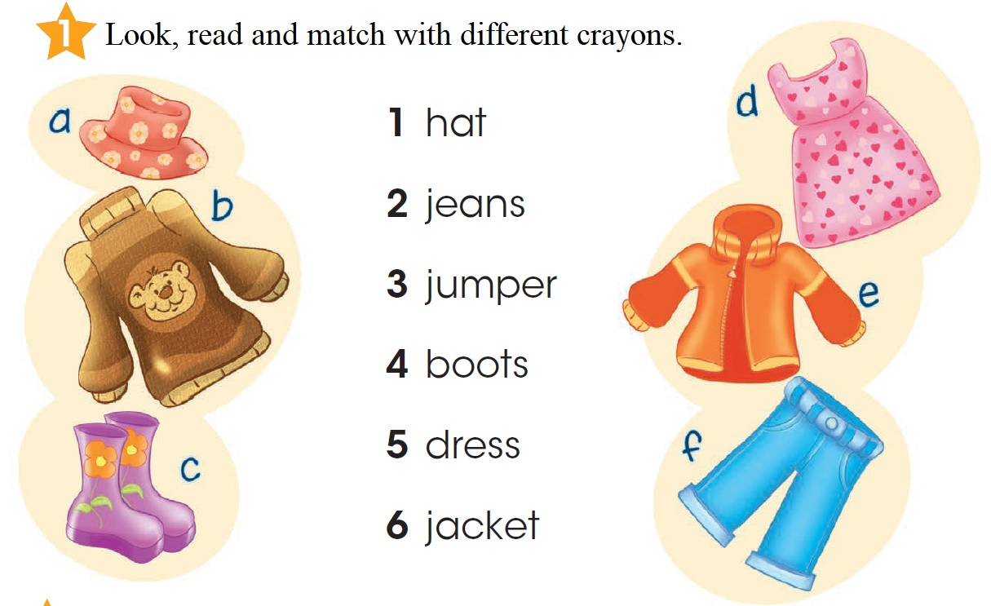

LESSON SCHEME

- WARM UP – 3 MIN [8:55 – 8:58 ]
- GREETINGS
- ATTENDANCE

- LEAD–IN – 5 MIN [ 8:58 - 9:03 ]
- TITLE + DATE
- LESSON’S AIMS
- RAINBOW SONG

- REVISION OF THE THEORETICAL PART - 10 MIN [ 9:03 – 9:13 ]
- GAME – BIT BY BIT (FRUIT & VEGETABLES)
- PUT THE FLASHCARDS INTO THE CORRECT BASKET
- WRITE THE FRUIT / VEGETABLES IN THE CORRECT COLUMN

- VOCABULARY GUIDED PRACTICE – 10 MIN [ 9:13 – 9:23 )
- EX 2 / PAGE 22 - MR / MRS
- INDIVIDUAL WORK: CHILDREN COLOUR THE FRUIT / VEGETABLES TEMPLATES
- GROUP – CLASS WORK: CHILDREN PRESENT THEIR FRUIT / VEGETABLES CHARACTERS: I’M MRS. ORANGE

- LANGUAGE GUIDED PRACTICE - 10 MIN [ 9:23 – 9:33 ]
- EX 3 / PAGE 23
- PAIR WORK: ASK AND ANSWER: WHAT’S YOUR FAVOURITE FRUIT? ORANGE! I LOVE ORANGES!

- FEEDBACK – 5 MIN [ 9:33 – 9:38 ]
- DID YOU ENJOY THIS ACTIVITY?
- WHICH ACTIVITY IN THE UNIT DID YOU LIKE BEST?
- POSITIVE POINTS REWARD

- HOMEWORK ASSIGNMENT – 2 MIN [ 9:38 – 9:40 ]
- EX 4 / PAGE 2E – ON A SEPARATE PAPER, IN YOUR PORTFOLIO

